Normalization 1
Benefits of Normalization 1
First Normal Form (1NF) – Remove Repeating Groups 1
Second Normal Form (2NF) – Removal of Partial Dependencies 2
Third Normal form (3NF) – Removal of Transitive Dependencies 2
Dependency Diagrams 3
Normalization Conclusion 4
Decision Support Systems 4
Data Warehousing 4
Star Schema 4
OLAP 5

Normalization
Normalization is used to make each row atomic. Atomic means the tuple cannot be broken down further. Normalization is performed:
- to reduce data redundancy and data anomalies.
- to make your data stronger and more flexible

Benefits of Normalization
When the normalization process is done:
- Each table represents a single subject
- No data item will be unnecessarily stored in more than one table
- All attributes in a table are dependent on the primary key

First Normal Form (1NF) – Remove Repeating Groups
In 1NF, primary keys are chosen and duplicated columns are moved to another table. For example:

Example 1
Student_Grade_Report(Studentno, student_name, major,course_no, course_name, instructor_no, instructor_name, instructor_location, grade)

Becomes:
Student (Student_no, student_name, major)
Student_Course (Studentno, course_no, course_name, instructor_no,instructor_name, instructor_location, grade)

Example 2
Project_Assignment(Proj_Num, Proj_Name, Emp_Num, Emp_Name, Skill_Class, Chg_hour, Assign_Hours)

Becomes:
Project_Assignment(Proj_Num, Emp_Num, Proj_Name, Assign_Hours)
Employee(Emp_Num, Emp_Name, Skill_Class, Chg_hour)

Second Normal Form (2NF) – Removal of Partial Dependencies
2NF involves removing attributes that are not totally dependent on the primary key. 2NF is only necessary if the primary key is a composite key. If the tuple is already in 1NF and does not use a composite primary key it is already in 2NF.

Example 1
In 2NF, example 1 becomes:

Student (Studentno,student_name,major)
Course_Grade (studentno,course_no,grade)
Course_Instructor(Course_no, course_name, instructor_no, instructor_name, nstructor_location)

Example 2
In example 2, project name does not depend on project assignment so a project table is created.
Project(Proj_Num, Proj_Name)
Project_Assignment(Proj_Num, Emp_Num, Assign_Hours)
Employee(Emp_Num, Emp_Name, Skill_Class, Chg_hour)

Third Normal form (3NF) – Removal of Transitive Dependencies
3NF involves removal of attributes that are not dependent on the primary key.

Example 1
In 3NF, instructor does not rely on Course_no in any way so a new table is created for instructor information:

Student (Studentno, student_name, major)
Course_Grade (Studentno, course_no, grade)
Course (Course_no,course_name,instructor_no)
Instructor (Instructor_no, instructor_name, instructor_location)

Example 2
In example 2, Skill_Class does not depend on Emp_Num so it should be moved to a separate tuple:

Project(Proj_Num, Proj_Name)
Project_Assignment(Proj_Num, Emp_Num, Assign_Hours)
Employee(Emp_Num, Emp_Name, Skill_Class)
Skill(Skill_Class, Chg_hour)

Rename entities and set keys accordingly.
A data warehouse is a repository for historical data for essential record keeping and trend analysis. The data warehouse is designed to offer efficient performance to support queries that are used for making business decisions.

Dependency Diagrams
A dependency diagram can be used to assist in normalization for transforming a tuple in 1NF to 2NF and 3NF. A dependency diagram is used to map out partial and transitive dependencies between attributes.

For example, a company currently stores their data as shown here:

Attribute Name | Sample Value | Sample Value | Sample Value
INV_NUM | 211347 | 211347 | 211347
PROD_NUM | AA-E3422QW | QD-300932X | RU-995748G
SALE_DATE | 15-Jan-2006 | 15-Jan-2006 | 15-Jan-2006
PROD_DESCRIPTION | Rotary sander | 0.25-in. drill bit | Band saw
VEND_CODE | 211 | 211 | 309
VEND_NAME | NeverFail, Inc. | NeverFail, Inc. | BeGood, Inc.
NUM_SOLD | 1 | 8 | 1
PROD_PRICE | $49.95 | $3.45 | $39.99

They summarize their table in 1NF as follows:

A dependency diagram can be used to map out the partial (2NF) and transitive (3NF) dependencies.

In this case, all attributes depend on the composite primary key.

PROD_NUM is part of the primary key but the product information is only partially dependent on the composite key so it is grouped separately.

INV_NUM is also part of the primary key and SALE_DATE only relies on this attribute so this is group of attributes are clustered together as a partial dependent group.

Within the product partial dependency, vendor is not dependent on PROD_NUM in any way. For this reason, VEND_CODE and VEND_NAME are grouped as a transitive dependency.

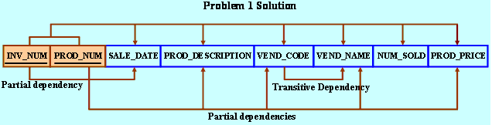
- Dependency diagram

The dependency diagram can then be used to break the attributes down into 2NF and 3NF. Here is the final result in 3NF.
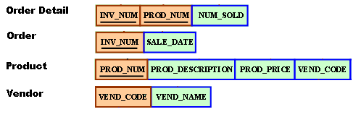
Note, while transforming attributes into 3NF, to ensure a coherent and readable data model, the table names and attribute names should also be modified to represent the data which they describe.

Normalization Conclusion
Most of the time it is faster to just express the attributes in 3NF instead of breaking a cluster of attributes into 1NF, 2NF, and 3NF. Sometimes, due to business constraints or customer requirements it may not be possible to break a table down into 3NF. Regardless, normalization provides useful logic to break complex tuples down for relational databases and can be used as a guide during the process.

Decision Support Systems
Good decision support systems not only use current operational data. Decision support systems also need good historical data to support querying and data mining for discovering trends and for making predictions. Depending on the volume of data used on a daily basis and the volume of historical data, it may make sense to warehouse your data.

Data Warehousing
Until now, the relational data systems discussed have referred to operational data for current data. However, data warehousing may be used to store data for the long term. Data maintained through data warehousing is typically for tracking core historical data and for enabling trend analysis and forecasting. Here are some key differences between operational and data warehouse data (thank you Harry):

Operational | Warehouse
Small database | Large Database
Transaction oriented | Higher level business oriented
Up to date data | Historical data
Continuous updates | Batch updates
Normalized data | Denormalized data

Star Schema
A star schema is often used to create a foundation for a data warehouse. The star schema creates a multidimensional database which enables easy comparisons between dimensions. The central fact table is related to the surrounding dimension tables through its composite primary key, which is derived from the primary keys of each dimension table. Data warehouses can have many fact tables in order to capitalize on the efficiency of this design. Here is a sample star schema: (Thank you Kathleen)
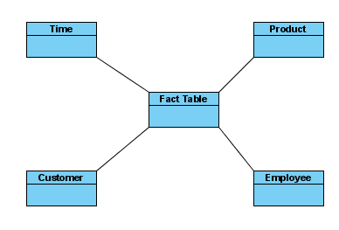

To enable faster querying on large volumes of data, dimension tables will often store summaries such as totals, averages, maximums and others. Summaries in any form of schema are known as aggregates. Since historical data is stored in a data warehouse derived attributes (calculated attributes such as age) are stored in the data warehouse to show a snapshot from the period of time being analyzed or compared.

OLAP
OLAP stands for On Line Analytical Processing. OLAP provides an interface to combine large volumes of data with summaries and projections in a compiled format that can be accessed quickly for data analysis. OLAP is one part of a decision support system which permits analysis of large volumes of data. Typically OLAP is used to report off a data warehouse but it can be used with operational data as well.

OLAP is valuable as an analytical tool however it is limited in scope. The cost to implement an OLAP system is a barrier for smaller operations so it usually only included in decision support systems for larger organizations.

OLAP data is stored in a multi-dimensional cube. The dimensions can be interchanged to provide different comparisons. OLAP data is also hierarchical which enables drill down to view data summaries (aggregation) at each level. Ie. You might view total income or total revenue at a State, City, or Store level by drilling down from one level to the next.

Cube Generation Video
The Cube Generation video shows the creation of a cube using MS Analysis Services for SQL Server 2000. Note that the cube is generated from a regular relational database. A star schema is used to build the cube. Each table is called a dimension. At the center of the star schema, a fact table placed. The fact table contains primary keys which relate to each of the dimension tables. Once all dimensions are added, the cube is compiled into binary format for fast access.

Note: It is also possible to add calculated fields and even graphical analysis for further data discovery.

OLAP Reporting
The figure below shows reporting on a cube. The Customer and Education dimension are being analyzed. It is possible to drill down on country to state and then city. At each drill down the education totals will re-project themselves to new values according to the position in the hierarchy. It is also possible to drill down on Education to other sublevels. Again the aggregate values will re-project themselves accordingly. The Education and Customer dimensions being analyzed can be swapped with the dimensions on the left panel.
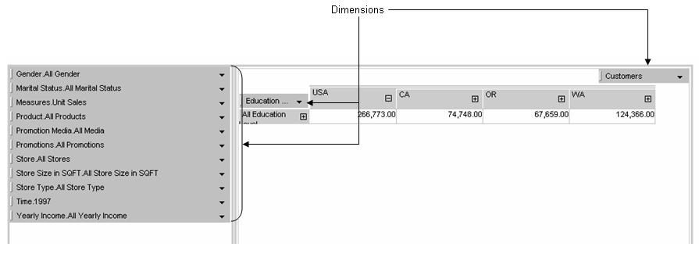
It is also possible to cluster dimensions. Notice in the figure below two dimensions Yearly Income and Gender are grouped together to provide Customer information.
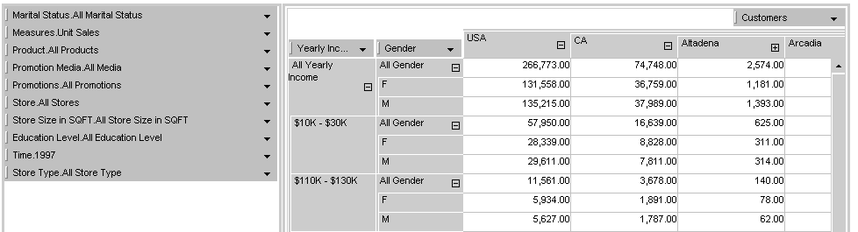

OLAP Reporting Video
This video shows the creation of an OLAP report. It shows how dimensions can be added to create a table of data. The dimensions can be drilled on to produce summaries of data at each level in the hierarchy. Dimensions can easily be swapped to provide different views of the data and to generate different query results. Dimensions can also be grouped either in the rows or columns of the table.

